**JAVA TEST 8**  
**SET 2**

**Q-01:**

package circle;

interface Shape {

double getArea();

}

class Rectangle implements Shape {

private double width;

private double height;

public Rectangle(double width, double height) {

this.width = width;

this.height = height;

}

public double getArea() {

return width * height;

}

}

class Circle implements Shape {

private double radius;

public Circle(double radius) {

this.radius = radius;

}

public double getArea() {

return Math.***PI*** * radius * radius; // Incorrect value for PI

}

}

public class Main {

public static void main(String[] args) {

Shape rectangle = new Rectangle(5, 10);

Shape circle = new Circle(7);

System.***out***.println("Rectangle Area:"+

rectangle.getArea());

System.***out***.println("Circle Area: " +

circle.getArea());

}

}

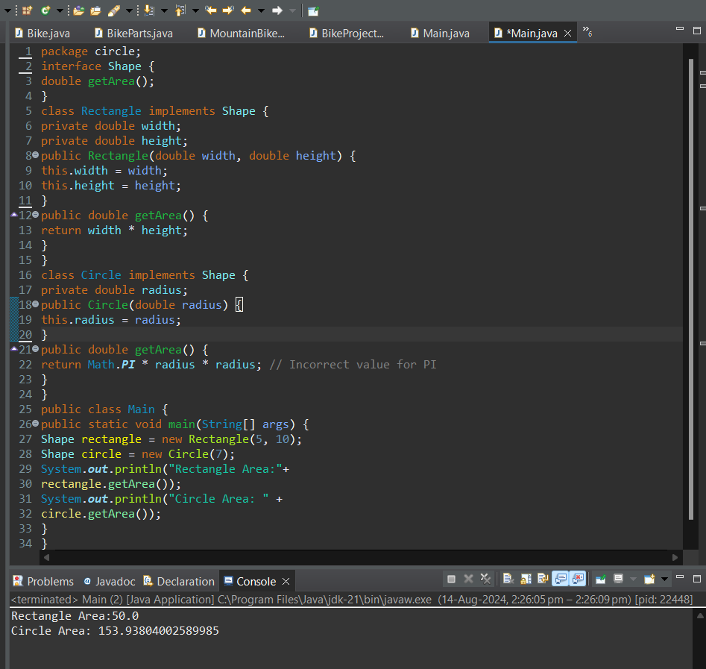

**Q-02:**

package employee;

abstract class Employee {

protected String name;

public Employee(String name) {

this.name = name;

}

abstract void performDuties();

}

class Manager extends Employee {

public Manager(String name) {

super(name);

}

*@Override*

void performDuties() {

System.***out***.println(name + " is managing the team.");

}

}

class Developer extends Employee {

public Developer(String name) {

super(name);

}

void performDuties() {

System.***out***.println(name + " is coding.");

}

}

public class Main {

public static void main(String[] args) {

Employee manager = new Manager("Alice");

Employee developer = new Developer("Bob");

manager.performDuties();

developer.performDuties();

}

}

